**LOAD CELL AUTOMATION**

**Contents:**

1. **How It Works**
2. **How to read the files**
3. **Errors**
4. **Limitations of the Setup**
5. **Future Scope**
6. **HOW IT WORKS:**
7. The setup is designed in such a way that it can indicates the highest measured value of **Weight** is in range or not.
8. The setup consists of a **Weight Transmitter Meter** connected to a **RS-485 to TTL Converter Module** which is further connected with **Arduino Nano Board.** The board has GPIO pins connected to the following components-

**Red LED - x 01**

**Green LED - x 01**

**Rotary Encoder - x 01**

**LCD Display - x 01**

**Push Button - x 01**

**Micro SD Card Reader Module x 01**

**RS-485 to TTL Converter Module x 01**

1. In this setup, **MODBUS RTU** is used as Communication protocols with the help of **RS-485**. Where Arduino Nano works as **Master** and Weight Transmitter Meter is used as **Slave**.
2. The setup has a **Power Switch** on the board and a Push Button to reset/reinitialize the setup. After pressing the Power Switch, the System will start initializing itself. The System is designed to check whether the Weight Transmitter is properly connected or not. If it is not connected with the system, it will display Error message on LCD Screen that “**Meter Disconnected**” as shown below.

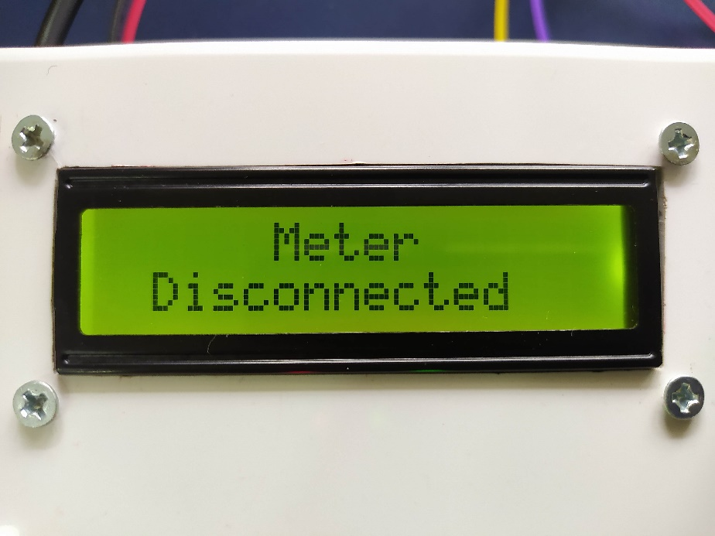

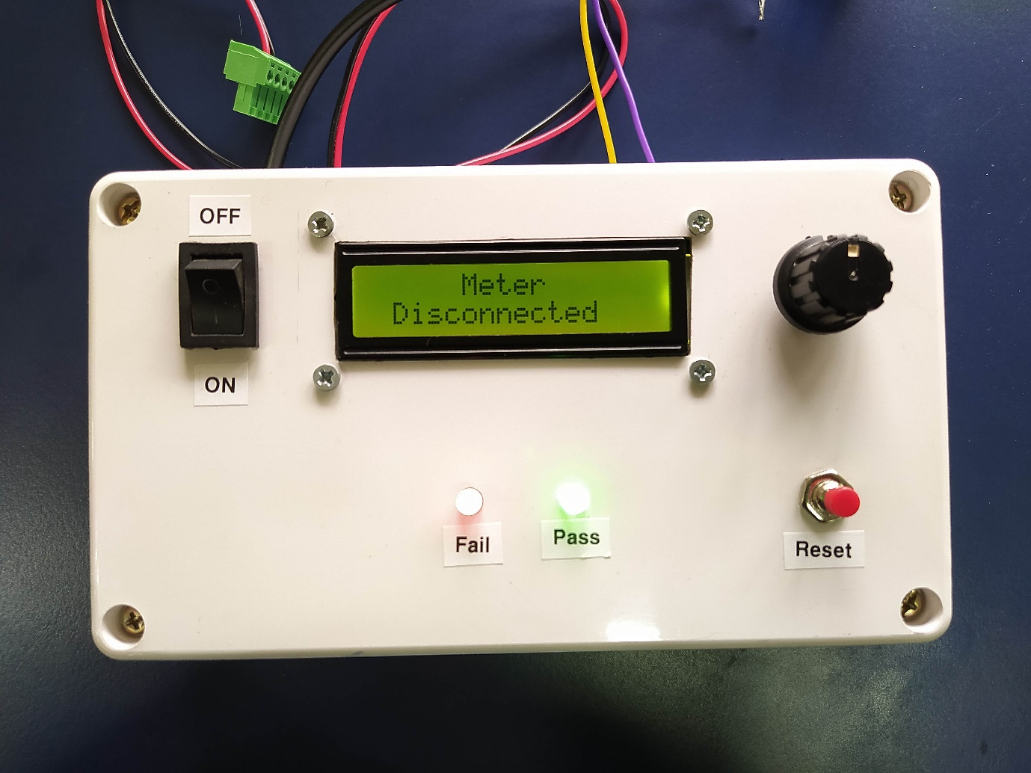

1. The User has to connect the Weight Transmitter properly and press the Reset Button.
2. Now coming to the Weight Transmitter part, it works on the **Modbus RTU protocols** and serves as a Slave device as we discussed earlier.

Its **Slave ID is 1**, **Baud rate is 19200** and **0x07 register address** is used to read the weight value. There are ports on the meter to connect **Load cell** and **RS-485 to TTL Converter Module** over there.

1. The Weight Transmitter meter will show reading on the display After applying Force on the Load Cell as shown below.

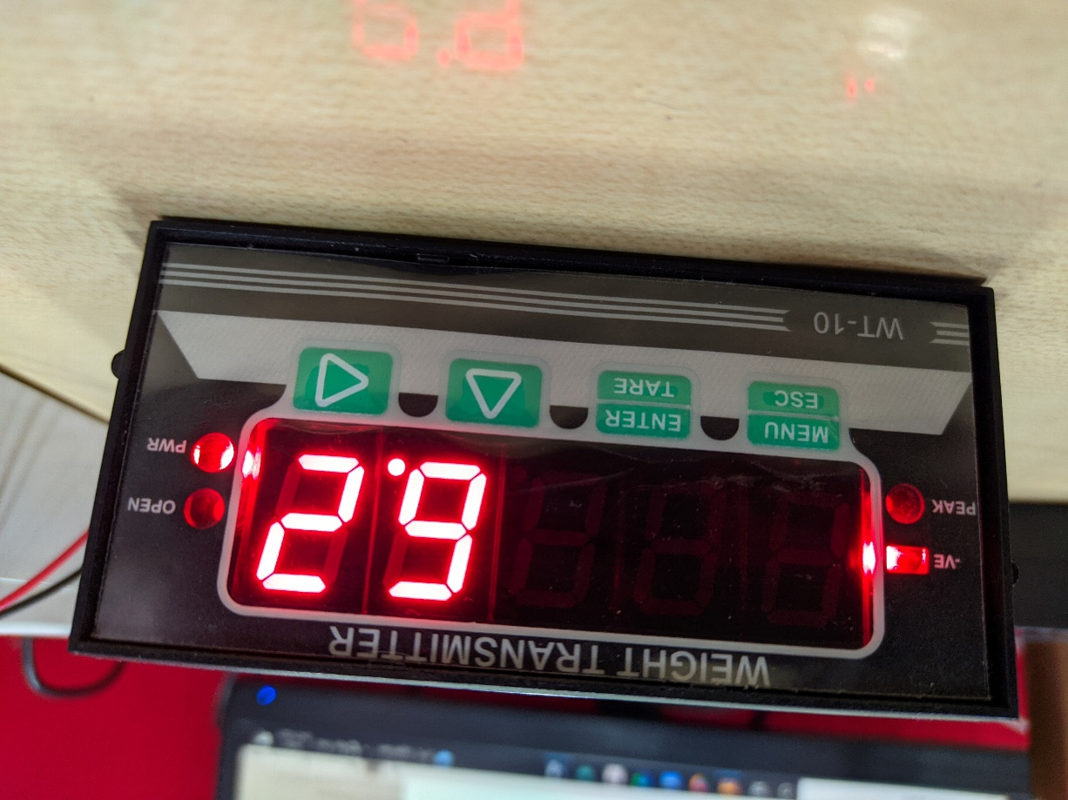

1. The user need to set the range for minimum force (F_Min) by using rotary encoder, steps for setting the minimum force are as follows –

* **1. Steps-** Press the **Reset Button** and release it once, after that press the **Encoder Switch** until it shows the Setting mode on the **LCD Display** and then release it also.

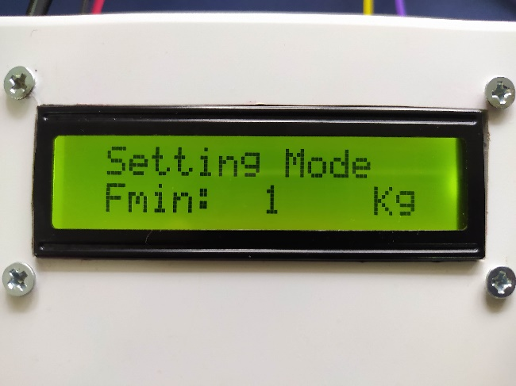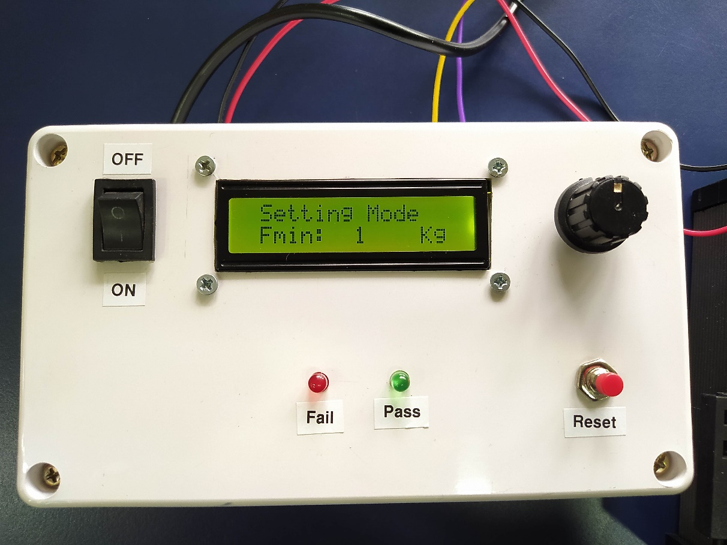

* **2. Steps-** After entering to Setting mode, Adjust the **F_Min** (Minimum Force) by rotating the **Rotary Encoder knob.** To set the adjusted value in EEPROM, press the **Rotary Encoder knob.**

 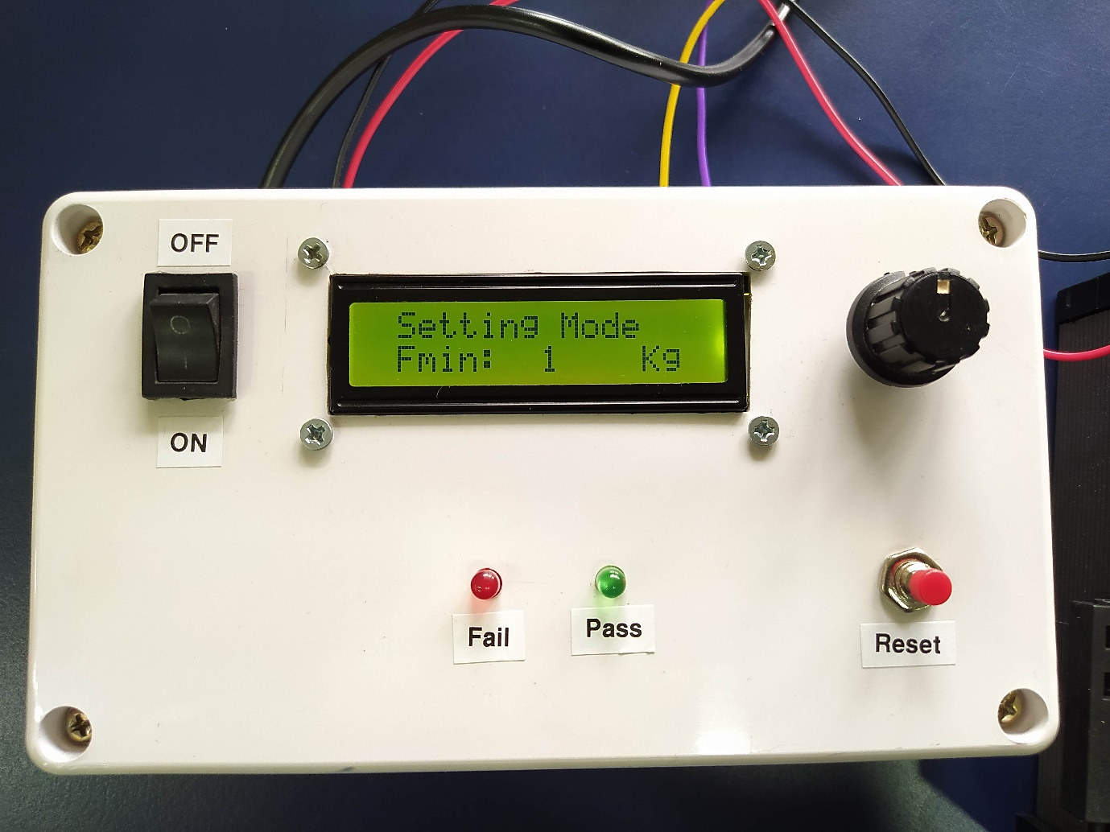

* **3. Steps-** For taking new readings, press the Reset Switch.

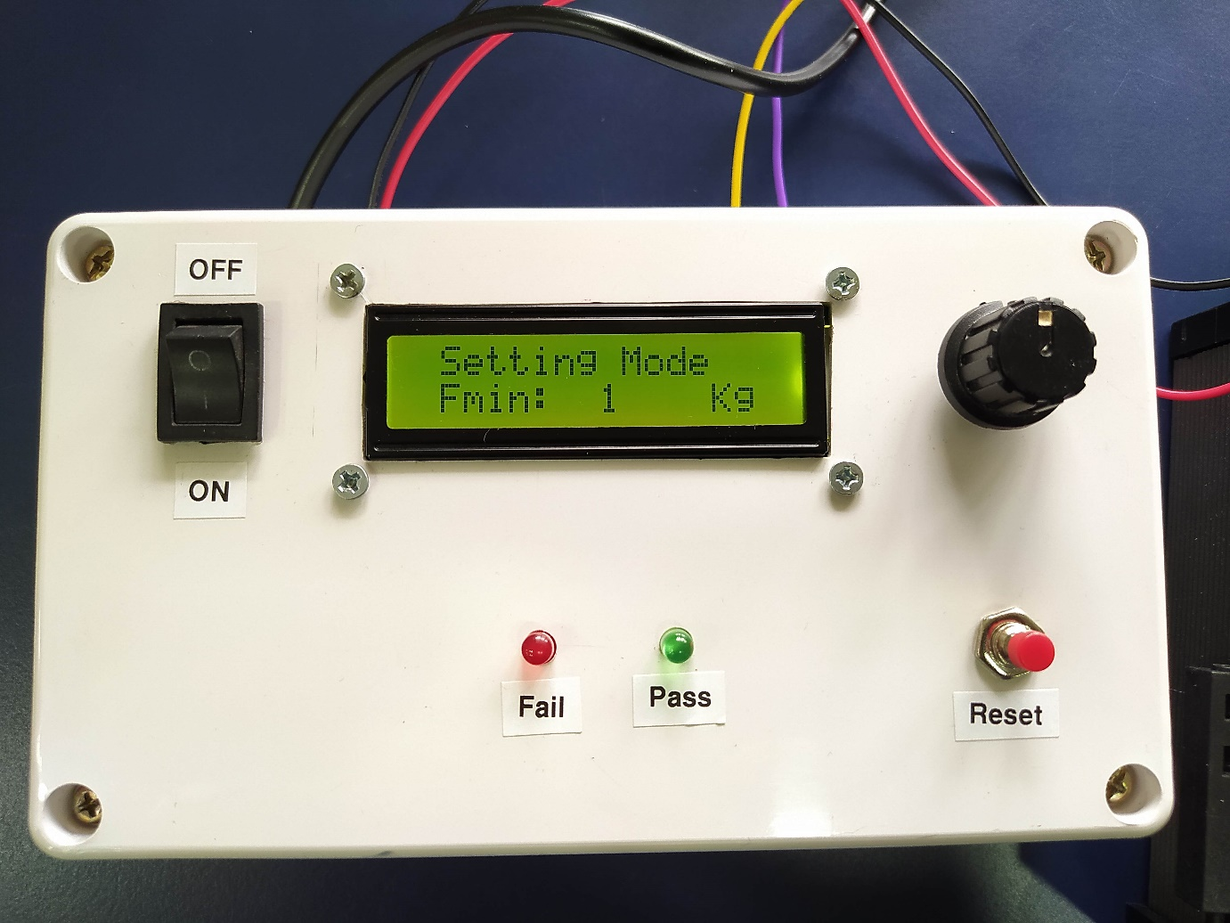

1. For taking every new reading user need to press Reset Button, now system is ready for accepting new reading and “Measuring Mode” with “F_Min” will be displayed on LCD Screen as shown below-

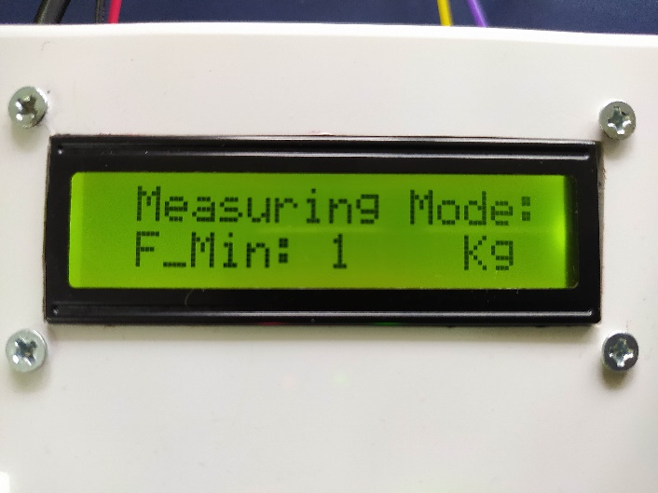

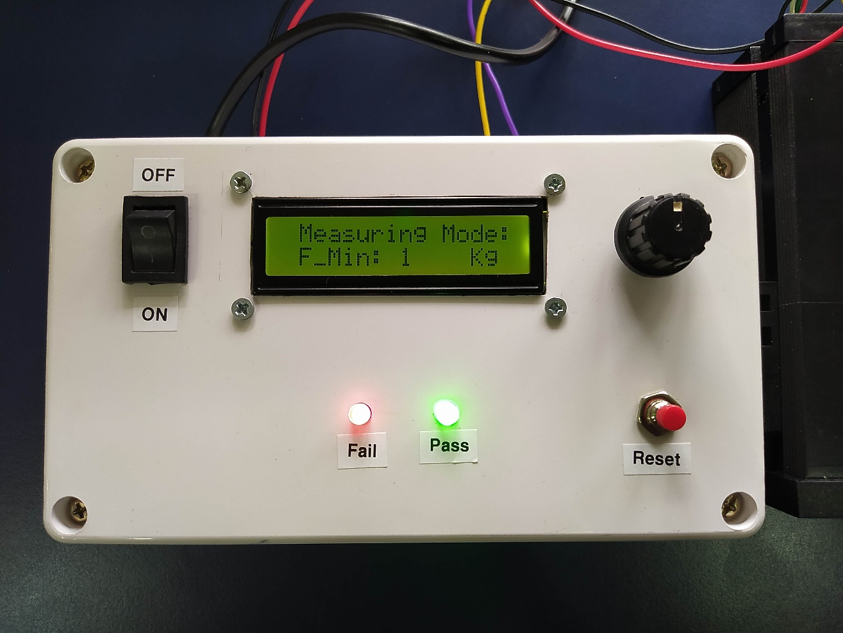

1. **Now Arduino Nano** (**Master Device**) continuously requests the measured value from the **Weight Transmitter Meter** (**Slave Device**). And then it shows **PASS / FAIL** results by compare it with the **F_Min** (Minimum fore). If the received value is less than F_Min it will shows FAIL result and vice versa… as shown below

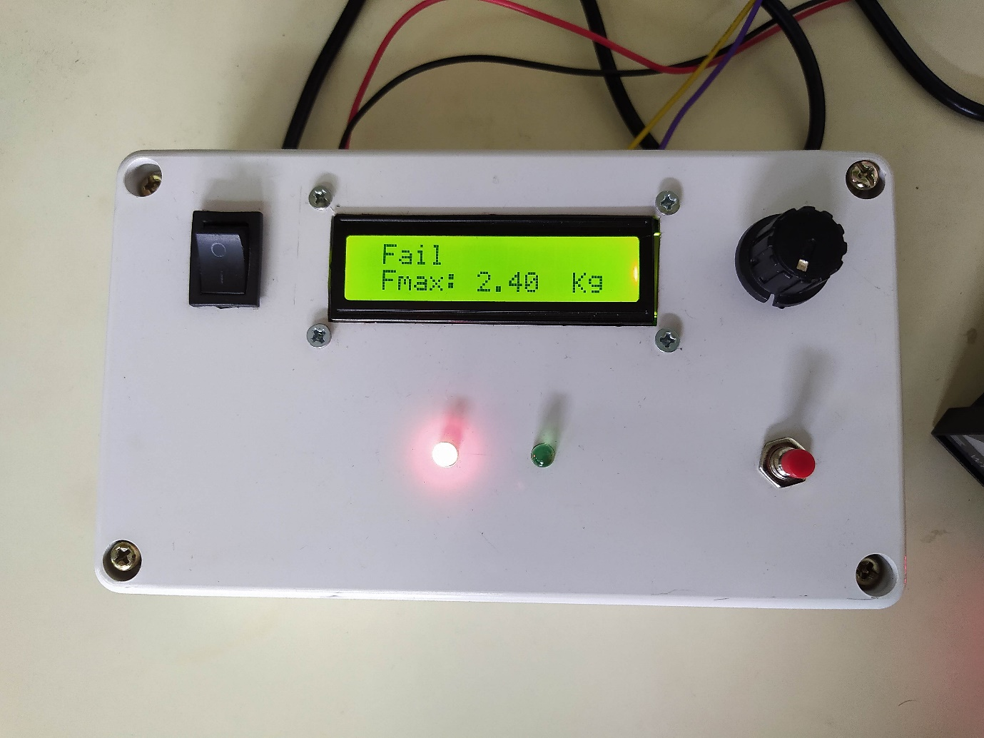

FAIL

RESET

PASS

ON

OFF

**Result: FAIL**

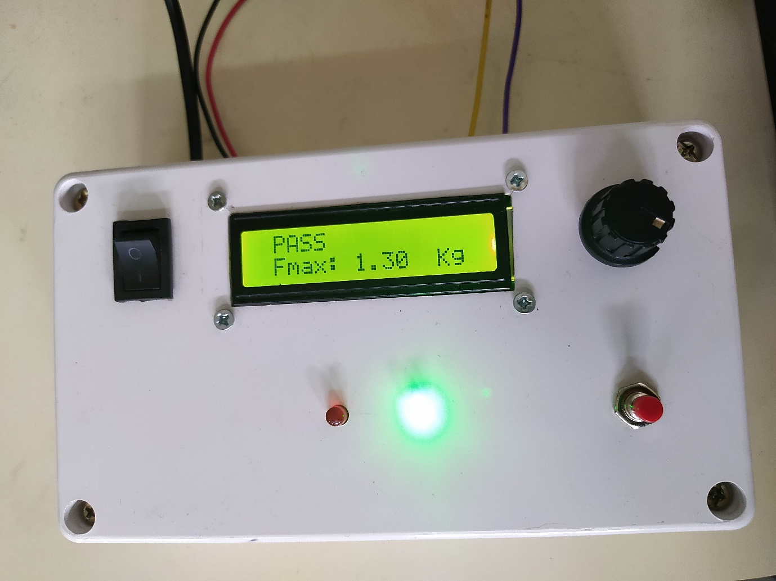

RESET

PASS

FAIL

ON

OFF

**Result: PASS**

1. And finally stores the results on the **Micro SD Card**.
2. **HOW TO READ THE FILES:**
3. For reading the stored results, user need to turn off the system then take out the **Micro SD Card** from the device after that insert it to the computer using **Micro SD Card Reader**

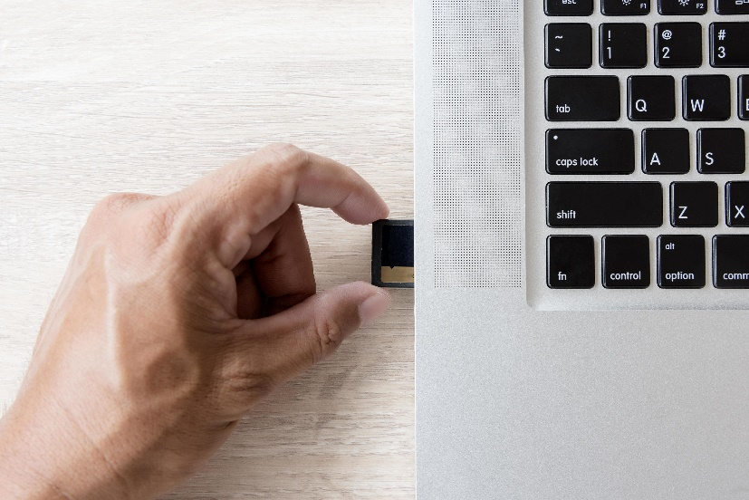

1. The data file is stored as the “**TEXT.csv**” in the Micro SD Card.
2. The file can be opened as an Excel sheet having following data:

F_Min (KG), F_Max (KG), Results.

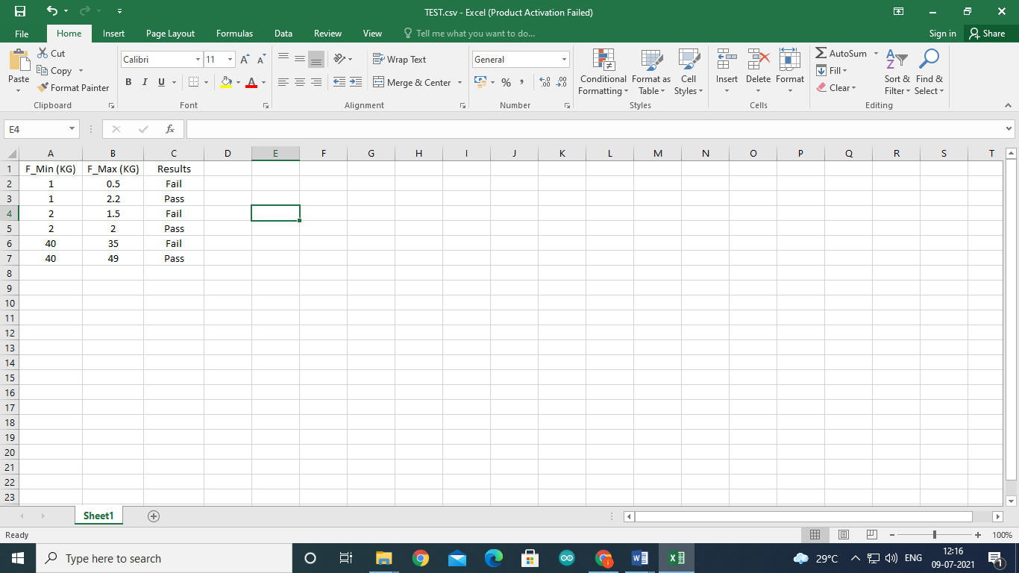

1. **ERROR**
2. **LED not Glow at initialization…**
   * 1. This may happen due to several reasons like…
3. There may be lose connection between System and Power Supply or between LED and Arduino Board.
4. May be the LED is fused…
5. **LCD Display not working**
6. There may be lose connection between System and Power Supply or between LCD and Arduino Board.
7. **Continuously showing “Meter Disconnected” on LCD**
8. It may be happening due to lose connection between System and Weight Transmitter Meter.
9. Or the Weight Transmitter has not started.
10. **If someone remove Micro SD Card in between the process**
11. If someone remove the Micro SD Card in between the process, It will not affect the system. Only result will not store in SD Card.
12. **LIMITATIONS**
13. **Always start new reading when Weight Transmitter’s reading becomes Zero.**

Otherwise the system will consider it as a new data and start concluding the results, Hence False data will be stored in SD Card.

1. **Use 24V DC Power Supply**
2. **Future Scope**
3. The Sy